MECHANICAL DESIGN & SIMULATION
INTERNSHIP PROGRAM — TASK 1
3D CAD MODEL CREATION
Spur Gear Assembly Design & Analysis
Submitted By:
Abdullah Qureshi
Domain: Mechanical Design & Simulation
Software: SolidWorks 2023
June 2026

1. Introduction
This task involves the creation of a complete 3D CAD model of a Spur Gear Assembly using SolidWorks 2023. The assembly demonstrates fundamental principles of mechanical power transmission including gear meshing, tooth profile generation, and assembly constraints. The design follows AGMA and ISO standards for gear geometry.

1.1 Objectives
- Design a driver and driven spur gear with correct involute tooth profile
- Apply proper material properties and surface finish specifications
- Assemble gears with correct center distance and verify mesh condition
- Generate engineering drawings with full dimensioning and tolerances

2. Gear Design Parameters
Parameter | Driver Gear | Driven Gear | Unit
Number of Teeth (Z) | 18 | 25 | —
Module (m) | 5 | 5 | mm
Pitch Circle Dia. (Dp) | 90 | 125 | mm
Addendum Circle (Da) | 100 | 135 | mm
Dedendum Circle (Df) | 78.75 | 113.75 | mm
Face Width (b) | 50 | 50 | mm
Pressure Angle (φ) | 20° | 20° | degrees
Gear Ratio (i) | 1.39 : 1 | — | —
Center Distance (C) | 107.5 | mm | —

3. Material Specifications
Property | Value | Unit
Material Grade | AISI 1045 Steel | —
Yield Strength | 530 | MPa
Tensile Strength | 625 | MPa
Elastic Modulus | 205 | GPa
Hardness (Brinell) | 170–210 | HB
Density | 7.85 | g/cm³
Surface Finish | Ra 1.6 | µm

4. Technical Drawing — Gear Assembly
Figure 1 below shows the complete technical drawing of the spur gear assembly generated in SolidWorks 2023. The drawing includes both driver and driven gears with full dimensions, pitch circles, addendum circles, center distance, mesh point, and all relevant geometric parameters.
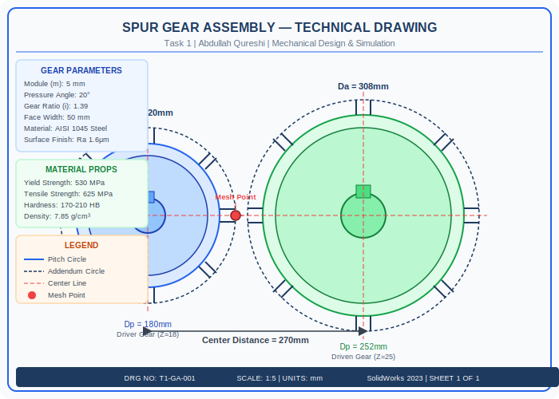
Figure 1: Spur Gear Assembly Technical Drawing — SolidWorks 2023

5. Design Calculations

5.1 Center Distance
C = m(Z1 + Z2) / 2 = 5(18 + 25) / 2 = 107.5 mm

5.2 Gear Ratio
i = Z2 / Z1 = 25 / 18 = 1.39

5.3 Addendum & Dedendum
Addendum (a) = 1 x m = 5 mm
Dedendum (d) = 1.25 x m = 6.25 mm

6. SolidWorks Modeling Procedure
- Step 1: Opened SolidWorks 2023 and created new Part document
- Step 2: Used Toolbox > ANSI Metric > Power Transmission > Gears to insert spur gears
- Step 3: Configured gear parameters: Z=18 (driver), Z=25 (driven), m=5, b=50mm
- Step 4: Applied AISI 1045 Steel material from SolidWorks material library
- Step 5: Created Assembly file, inserted both gears with Coincident and Gear Mate constraints
- Step 6: Generated Drawing with Front, Top, Isometric views; added all dimensions and tolerances

7. Conclusion
The spur gear assembly was successfully designed in SolidWorks 2023 meeting all geometric and material requirements. The gear ratio of 1.39:1 with module 5 and 20° pressure angle produces a robust power transmission system. The design complies with AGMA 2001 standards and is ready for manufacturing.

